In 1992, six years into our marriage, I had reached my limit. My husband had travelled to Namibia for a conference. He left with a threat of ending our marriage if things do not change on his return. How did two people go from loving each other so passionately to constant fights, quarrels, hurtful words and wondering why we ever got married? It seemed like we no longer loved each other.
One day, I attended a seminar that had nothing to do with marriage, but for some reason, the speaker began to share about her marriage and how it transformed to become the envy of others. I made up my mind that day that my marriage can be saved. I began to take steps toward making that needed transformation. We were married for almost 35years before he transitioned to glory in 2021.
You, too, can save your marriage.

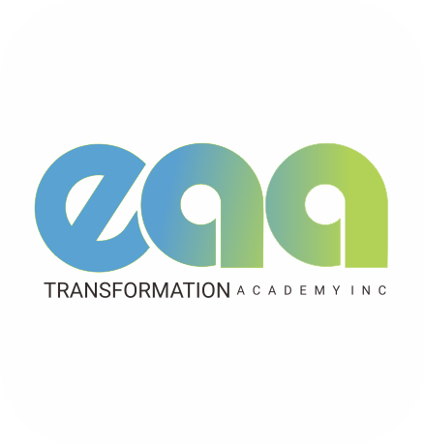
- Home
- Couples Relationship Checkup
- Wedding Officiant Services
- About
- Contact

Couples Relationship Checkup
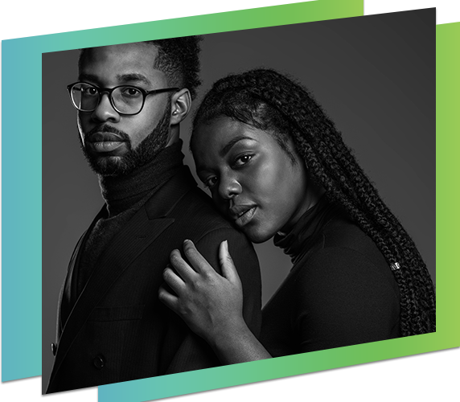
Are you growing together or growing apart?
If you cannot confidently say, “we are growing together,’ then you need
The Relationship Checkup
If you want to save your marriage, the first thing to do is to scientifically assess the state of your marriage using The Relationship Checkup tool.
The relationship checkup is a three-session intensive intervention for couples who desperately need to experience a change.
Stop the blaming and assumptions and get honest with each other
I use The Gottman Relationship checkup assessment tool developed from over 40 years of research by Dr. John Gottman. The tool relies on detailed and evidence based information on why relationships fail or succeed.
You and your partner will answer 480 in-depth questions covering friendship, intimacy, emotions, conflict, values and trust, spirituality, parenting, housework, finances, individual areas of concern and much more.
It is an innovative tool that saves you and me a lot of time trying to navigate the root causes of conflict in your relationship.
Once I get the assessment, it would help me know the likely intervention you need to get both of you back on track.

Session 1
Session 1 is an oral interview where each partner can express their feelings about their relationship and why they seek intervention.
I will also give you an overview of the Gottman relationship checkup tool.
This is a 90-minute session.
Between sessions 1 and 2
Each partner will accept the email invitation to complete the assessment, fill out their assessment independently of each other, and submit it when complete.
Please note that the assessment cannot be done unless both parties complete the questionnaires.
Once you have submitted it, the assessment will be done automatically, and the results will be sent to me. I will use this information alongside information from session 1 to understand better what is happening in your marriage and what intervention you would require.
It takes 2 hours to complete the assessment.
Session 2
After receiving the assessment, I like to review the results with each partner separately. This allows for clarity and freedom of expression.
At the end, I would have a clearer picture of where both of you are in your relationship and how we can work together with the help of the Holy Spirit.
This is an hour-long session per person.
Session 3
In this session, you both get to see your areas of strengths and areas of conflict without any bias. I am glad to let you know that there is wisdom for every situation, and with the help of the Holy Spirit and proven methodologies, I trust both of you can get back on track to a blissful marriage.
At the end of this session, you will determine whether continuing more sessions with me would be beneficial.
This is a 90-minute session.
Total Cost
$435
You can pay this in full or an initial deposit of $135 and, after that, $100 per session.

Copyright © EAA Transformational Academy Inc.



Learning area

Does this describe your marriage?
- Your spiritual life as a couple leaves little to be desired.
- You are no longer patient with each other.
- You don’t appear to agree so there is high conflict.
- You are not friends anymore.
- Trust has been broken.
- Too many intruders.
- You have been drifting apart.
- You are feeling like ending the marriage.
- Little or no sex.

Do you desire
- A deeper relationship with God for you and your spouse.
- More prayerful and spiritual spouse.
- To love each other wholeheartedly.
- Increased communication, intimacy, and oneness.
- A stronger sense of purpose.
- To wake up every day and thank God for the spouse you married.

How can you achieve this transformation?
- Understand the mystery of marriage and the power available to bring about transformation.
- Master the seven pillars of a sound relationship.
- Learn how to keep outsiders outside.
- Find the North Star of your relationship.
- Learn how to move from I to We.
- Get your sex life back.
- And much more

Save your marriage course helps hurting couples rediscover the joy of marriage so they can create an exciting marital adventure that will last a lifetime, fulfilling God-purpose and leaving a legacy for the next generation.

https://youtu.be/YV1DvJKvL7E

Make the Change

Take responsibility. Decide you can do something. Change always begins with one person who wants to see a change. Understand that taking responsibility is not the same as taking the blame

In this program, you will learn what you can start doing now to make your relationship work.
And there is more. When you sign up you will get the following bonuses.
One emotional Healing session, Live Q/A , Three One-one sessions
Trust me to help you as I have helped others.
Register today for the Save my Marriage Course

About Us
EAA Transformation Academy Inc. was officially registered on April 26, 2021.
It is an academy that provides training programs and workshops for Ministers, Authors, Couples, Parents as well as Children and Youth with developmental challenges.
The essence of the programs are to equip beneficiaries with practical tools and resources that will make them metamorphose to a stage where they can handle challenging circumstances in their Family Life, Ministry and Vocation.

Our
Vision
To become a certified family life academy that is sought after globally for centuries to come.

Our
Mission
To understand the core pain points of our clients and device the right tools and resources that will take them from where they are to where they want to be.
EAA Transformation Academy is the epitome of Emmanuel Adeyinka Akinbami. It is vocal, confident, bold, knowledgeable, a pacesetter, highly resourceful, diverse, inventive, innovative, scholarly, focused on family life, ministry, health and wellness.
It is his legacy of hope for families and ministers all over the world seeking to be the best versions of themselves.
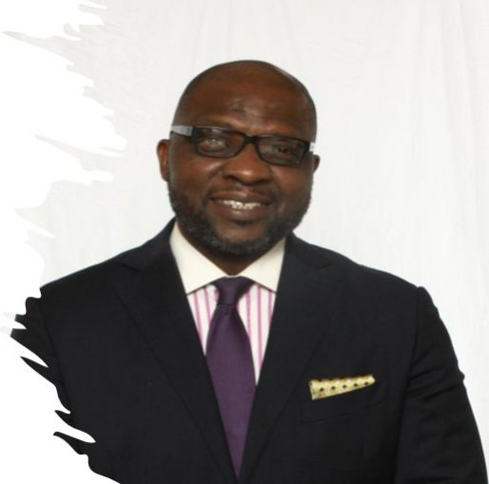

Wedding Officiant Services

I am a licensed Ontario wedding officiant. Building a blissful marriage starts with laying the right foundation. I am passionate about marriages I will be honoured to be a part of your marital journey by conducting your wedding ceremony.
Take a look at what I can do for you:

Simple Ceremony
This simple ceremony can be done anywhere, including your home.
The couple needs to have
- Filled out a relationship profile that enables me to know you a little better
- Have a marriage license
- Meet with me on Zoom before the payment deposit.
My Responsibilities
- I will give you a Record of the Solemnization of Marriage.
- I will send the completed marriage licence to be registered.
- Provide the communion elements
You can order your marriage certificate 10 – 12 weeks from the date your marriage took place.
Fee
$199
plus applicable taxes
Extra charges may apply depending on the distance.

Personalized Ceremony
A personalized ceremony would include rehearsals, a message of encouragement and taking communion during the ceremony.
The couple needs to have
- Filled out a relationship profile that enables me to know you a little better
- Have a marriage license
- Meet with me on Zoom before the payment deposit.
My Responsibilities
- I will give you a Record of the Solemnization of Marriage.
- I will send the completed marriage licence to be registered.
- You can order your marriage certificate 10 – 12 weeks from the date your marriage took place.
- Provide the communion elements
Fee
$299
plus $100 per hour of rehearsal and applicable taxes
Starting Right Pre-marital preparation. I offer on-demand pre-marital preparation classes.

Online Pre-Marriage Help

Short course
This covers
- Why marry
- What is marriage
- Are you rightly matched
These classes aim to give you an overview of God’s perspective on marriage. Through a series of questions, the couple becomes aware of their differences, and they both chart an intentional course to make their marriage work despite their differences.
If the couple is open to it, they will be invited to a time of prayer for their marriage
During this period, I get to meet both of you via Zoom. This allows you to ask questions and get clarity on any matter.
The online classes are taken at your own pace.
I strongly recommend these classes to everyone planning to get married.
Fee
$199
plus applicable taxes.
(extra charges apply depending on the distance)

Full course
To start off, the couple fills out the PQI and Family History Analysis form
The full course covers 10 sessions, all available online.
SESSION 1 – Why Marry? – Is it necessary to get married? After all, you can choose to cohabit.
SESSION 2- Are you rightly matched – (discussions around the filled PQI questionnaire. The session aims to point out that many assumptions are made when couples marry. It seeks to get the couple to discuss critical areas important to their marital journey and set intentions.
The goal of this session is to understand that being different does not mean you cannot become one, and where adjustments can be made, the couple chooses to adjust for the benefit of the whole.
SESSION 3 – What is marriage? Looks at God’s view of marriage and its purpose.
SESSION 4 – (2 SESSIONS) Marital Roles – first, looks at God’s expectations based on scripture for the husband and the wife. Discussions hover around the couple showing up and taking responsibility. Ephesians 4:15-16 and Romans 12:4-6 are key scriptures around marital roles.
SESSION 5 – Communication in marriage
SESSION 6 – Managing conflict
SESSION 7 – setting the proper boundaries.
SESSION 8 – SEX and keeping the wine
SESSION 9 – Theory of a sound relationship house – an overview of how the first year should go concerning your relationship.
*Book your relationship checkup
There are three live sessions – one after the PQI and family history analysis are filled, the second midway through the session and the third at the end.
Bonus session – Start right by setting your goals as a couple
At the end of this course, the couple is invited to create a vision board for the next five years.
Fee
$499

Contact

We look forward to hearing from you!

You can reach us via the contact form.
Alternatively please write us an email or give us a call
- contact@eaaacademy.com
- +234 703 7914 298

plus applicable taxes.

